 | Year 12 Specialist  TEST 2  Monday 11 March 2019  TIME: 45 minutes working  Classpads allowed  One page of notes  45 marks 7 Questions

Name:_______________________________

Teacher: ____________________________

Note: All part questions worth more than 2 marks require working to obtain full marks.

Q1 (2 & 3 = 5 marks)
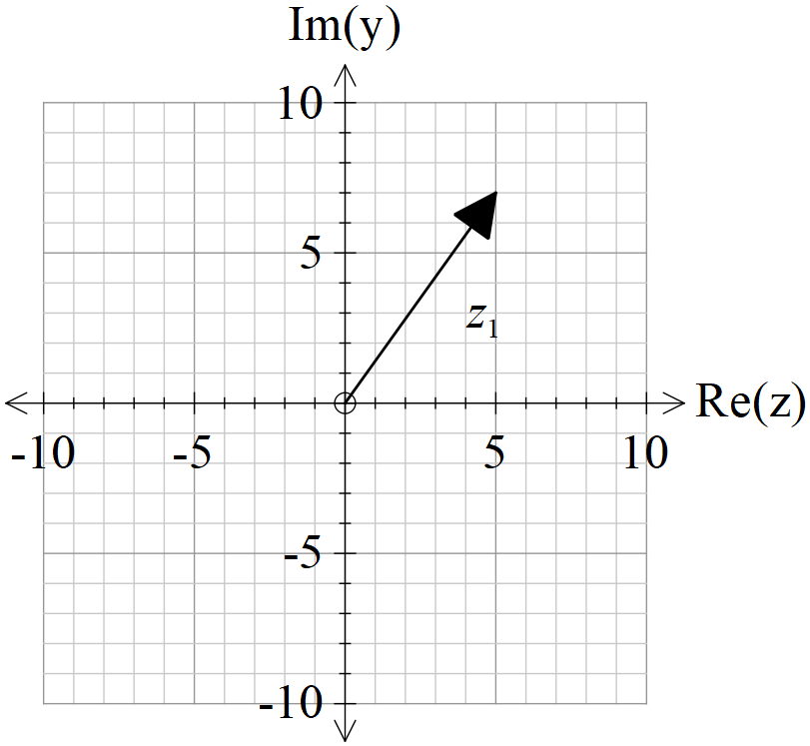
From the diagram, is a solution to for complex .
- Determine .

- Determine the other three roots and express in the form .

Q2 (2, 3 & 1 = 6 marks)
Let and .
- State the natural domain and range of .

- Does exist over the natural domain of ? If it does not, determine the largest possible domain for the composite to exist.

- Determine

Q3 (2, 3 & 2 = 7 marks)
Given that , , determine the following.
- and its domain.

- Sketch on the axes below,

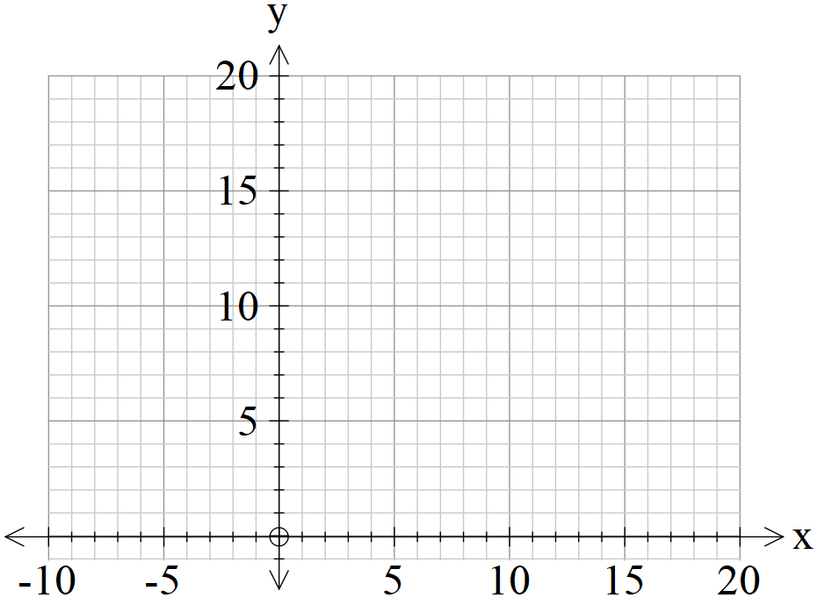

- On the sketch above show the precise points where

Q4 (2 & 3 = 5 marks)
Consider the function for the questions below.

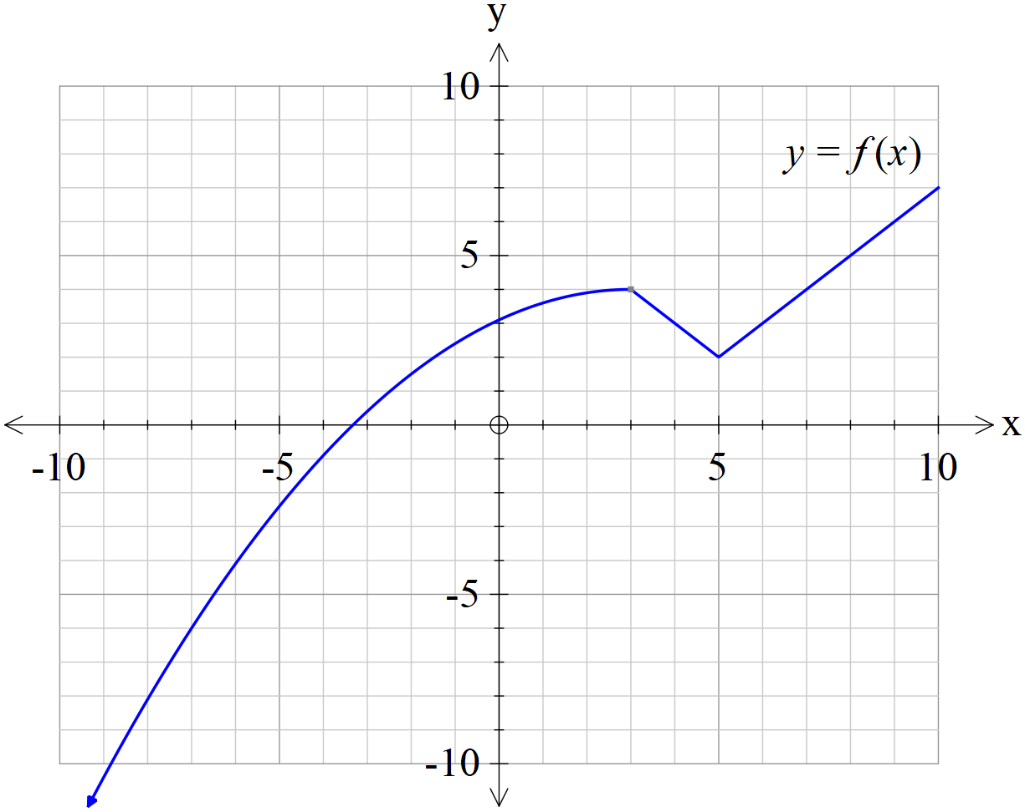

- Sketch the function on the axes below.

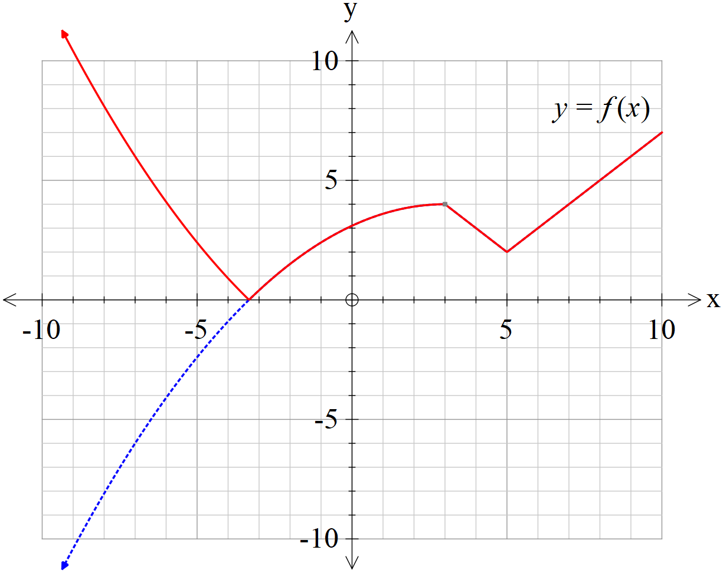

- Sketch the function on the axes below.

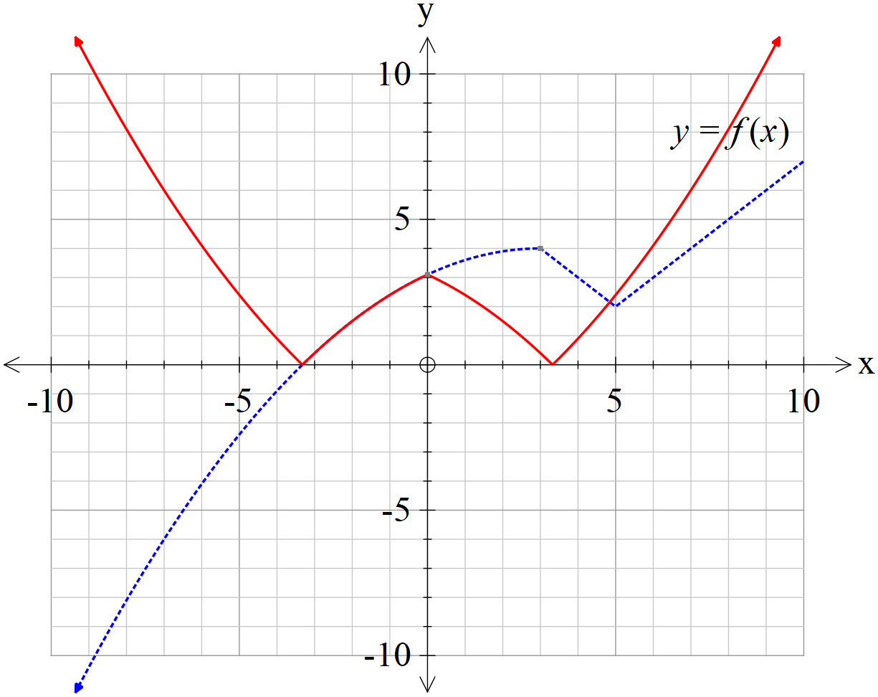

Q5 (3 & 4 = 7 marks)
Let be the plane defined y .
- Show that the cartesian equation of this plane is .

- Let the sphere have a centre , where is a constant, and it is known that the plane is tangential to this sphere. Determine the value ofand the vector equation of the sphere .

Q6 (1, 1, 1, 3, 1 & 3 =10 marks)
The diagram below shows a triangle with vertices with . Let be the origin, with vectors and .

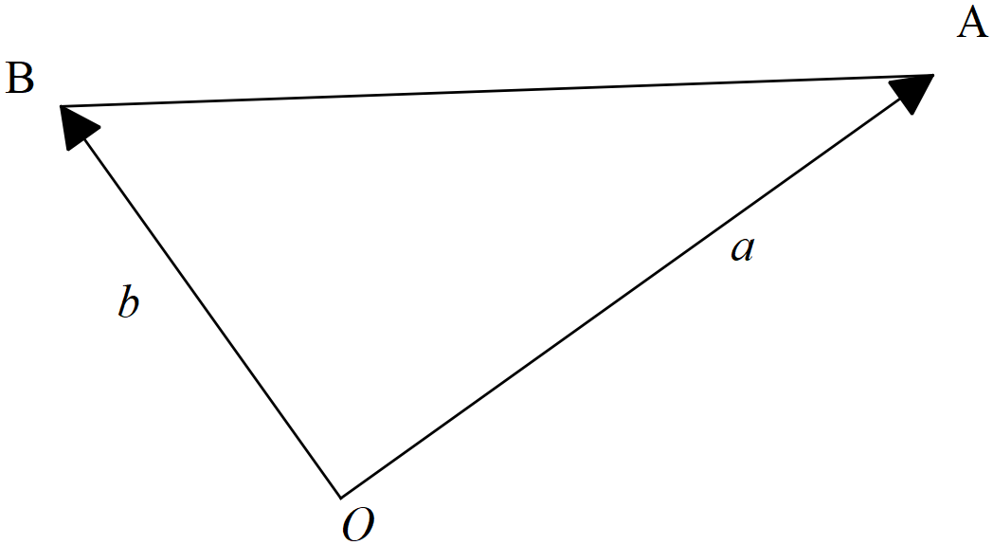

- Determine the following vectors in terms of .
- , where is the midpoint of the line segment .

ii)

- , where is the midpoint of the line segment .

Let be the midpoint of the line segment .
- Use a vector method tom prove that the quadrilateral is a parallelogram.

Q6 continued
Now consider the particular triangle with and where is a positive constant, chosen so that triangle is isosceles, with .
- Show that .

- Use a vector method to show that is perpendicular to .

Q7 (5 marks)
Let where is a real constant. Let , where are real constants. If for and all roots of satisfy , determine all possible values of .

